ELECENG 3CL4 – Lab 4
Phase Lead Compensation Using Root Locus

March 20th, 2026

Amaiam Ul Haque – haquea24 – 400520641 – L07 – C02
Jumana Ismail – ismailj – 400507846 – L07 – C02

Plagiarism Statement
As a future member of the engineering profession, the student is responsible for performing the required work in an honest manner, without plagiarism and cheating. Submitting this work with my name and student number is a statement and understanding that this work is my own and adheres to the Academic Integrity Policy of McMaster University and the Code of Conduct of the Professional Engineers of Ontario. Submitted by [Amaiam Ul-Haque, haquea24, 400520641]
As a future member of the engineering profession, the student is responsible for performing the required work in an honest manner, without plagiarism and cheating. Submitting this work with my name and student number is a statement and understanding that this work is my own and adheres to the Academic Integrity Policy of McMaster University and the Code of Conduct of the Professional Engineers of Ontario. Submitted by [Jumana Ismail, ismailj, 400507846]

Individual Contributions
- Pre Lab Report: both
- Design of Phase-Lead Compensator: both
- Experiment with Phase Lead Compensator: both
- Post Lab Report:
  - Typing Calculations: Amaiam
  - Formal Write Up: Jumana

Introduction
This objective of this lab is to design a phase lead compensator using root locus to achieve desired transit performance in a DC motor system. The controller’s performance is then evaluated through step and ramp response analysis to verify that the design meets the specified requirements.

Phase-Lead Control of the Servomechanism

Design of Phase-Lead Compensator
The transfer function of the plant / motor is as follows:
$$G\left(s\right)=\frac{A}{s\left(sτ_{m}+1\right)} =\frac{A/τ_{m}}{s\left(s+\frac{-1}{τ_{m}}\right)}$$

Given the lab station specific parameters: $A=29.34 , τ_{m}=0.0941$
$$G\left(s\right)=\frac{29.34}{s\left(0.0941s+1\right)} =\frac{311.8}{s\left(s+10.63\right)}$$

Given design requirements of $PO=10\% , T_{s}=0.3s$

To calculate the desired closed loop pole locations based on overshoot and settling time:
$$T_{s}=\frac{4}{real part of poles} \\ real part of poles=\frac{4}{T_{s}}=\frac{4}{0.3}=13.33$$
$$ζ=\frac{-\ln\left(\frac{PO}{100}\right)}{\sqrt{π^{2}±\ln^{2}\left(\frac{PO}{100}\right)}}=\frac{-\ln\left(0.1\right)}{\sqrt{π^{2}±\ln^{2}\left(0.1\right)}}=0.591 \\ ζ=cosθ \\ θ=\cos^{-1}{ζ=}\cos^{-1}{0.591}=53.772°$$
$$tanθ=\frac{opp}{adj}=\frac{y}{x} \\ y=xtanθ=real part of poles×tanθ=13.33\tan\left(53.772\right)=18.19 \\ img part of poles= ±18.19j$$
$$poles= -13.33±18.19j$$
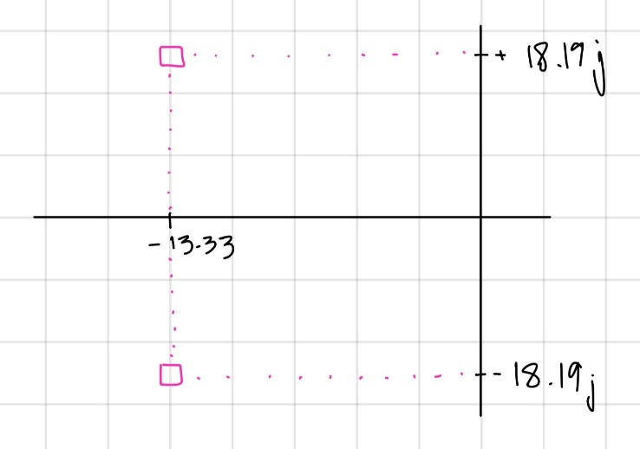

To calculate the phase lead compensator parameters $p, z$:
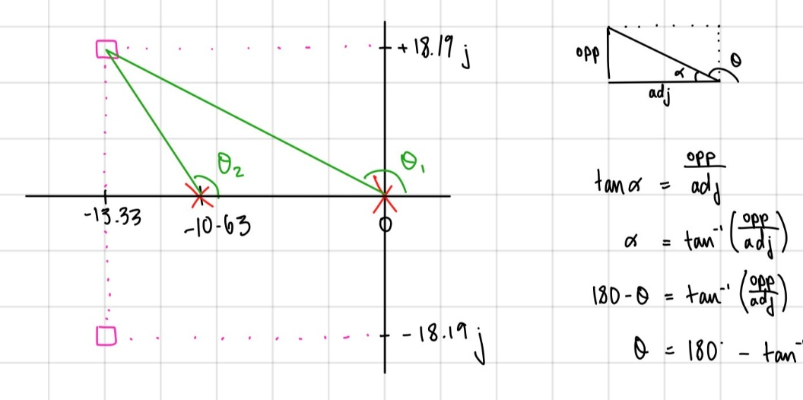
$$tanα=\frac{opp}{adj} \\ α=\tan^{-1}\left(\frac{opp}{adj}\right) , α=180°-θ \\ {180°-θ=tan}^{-1}\left(\frac{opp}{adj}\right) \\ {θ=180°-tan}^{-1}\left(\frac{opp}{adj}\right)$$

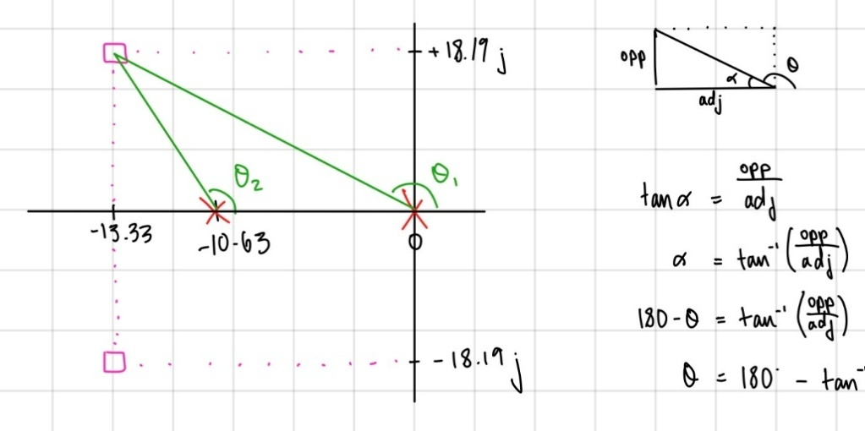
$${θ_{1}=180°-tan}^{-1}\left(\frac{opp}{adj}\right)={180°-tan}^{-1}\left(\frac{18.19}{13.33}\right)=126.23° \\ {θ_{2}=180°-tan}^{-1}\left(\frac{opp}{adj}\right)={180°-tan}^{-1}\left(\frac{18.19}{13.33-10.63}\right)=98.44° \\ 180°=ϕ_{c}-θ_{1}-θ_{2} \\ ϕ_{c}=-θ_{1}-θ_{2}-180°=-126.23-98.44-180=404.67=404.67-360=44.67°$$
$$θ_{z}=directly under σ_{A}=90° \\ ϕ_{c}=θ_{z}-θ_{p} \\ θ_{p}=θ_{z}-ϕ_{c}=90-44.67=45.33°$$

$$-z=-σ_{A} \\ -z=-13.33 \\ z=13.33$$

$$tanθ=\frac{y}{x} \\ x=\frac{y}{tanθ} , x=p-real part of pole=p-σ_{A} \\ p-σ_{A}=\frac{y}{tanθ} \\ p=\frac{y}{tanθ}+σ_{A}=\frac{18.19}{\tan\left(45.33\right)}+13.33=31.31$$

$$z=13.33, p=31.31$$
To sketch the root locus pic:
Relevant part of open loop transfer function: $P\left(s\right)=\frac{s+z}{s+p} ×G\left(s\right)=\frac{s+13.33}{s+31.31}×\frac{1}{s\left(s+10.63\right)}$
$$\# of open loop poles:n=3 \\ \# of open loop zeros:M=1 \\ \# of asymptotes:n-M=2 \\ angles: ϕ=\left(2l+1\right)\frac{180°}{n-M}=\left(2l+1\right)\frac{180°}{2}=\left(2l+1\right)90=90°, 270°→l=0,1 \\ centroid: σ_{A}=\frac{∑ pole positions-∑zero positions}{n-M}=\frac{31.31+10.63+0-13.33}{2}=14.3$$

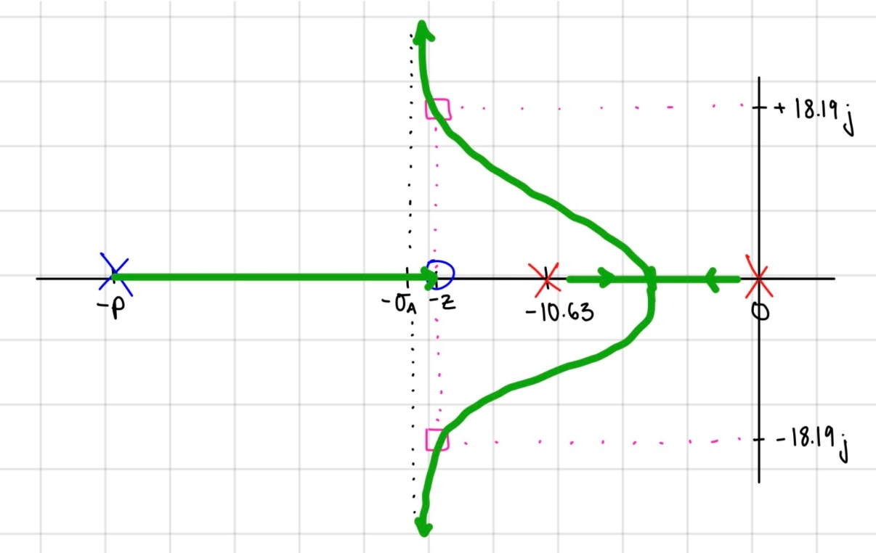

Using magnitude criterion to calculate the corresponding $k_{c}$:
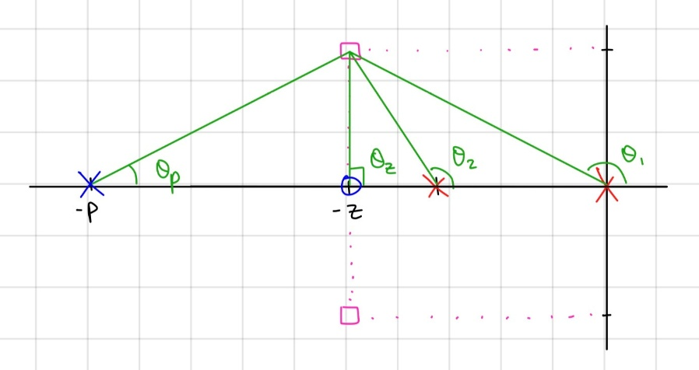
$$d=\sqrt{x^{2}+y^{2}} \\ d_{1}=\sqrt{{13.33}^{2}{+18.19}^{2} }=22.55$$
$$d_{2}=\sqrt{{(13.33-10.63)}^{2}{+18.19}^{2} }=18.39$$
$$d_{p}=\sqrt{{(31.31-13.33)}^{2}{+18.19}^{2} }=25.58$$
$$d_{z}=y=18.19$$

$$1=\left|G_{c}\left(s_{o}\right)G\left(s_{o}\right)\right| \\ k_{c}\left|\frac{s_{o}+z}{s_{o}+p}\right|=\frac{1}{\left|G_{c}\left(s_{o}\right)G\left(s_{o}\right)\right|} \\ k_{c}=\frac{1}{\left|G_{c}\left(s_{o}\right)G\left(s_{o}\right)\right|}×\left|\frac{s_{o}+p}{s_{o}+z}\right|=\frac{1}{311.8}×\frac{d_{1}d_{2}d_{p}}{d_{z}}=\frac{22.55×18.39×25.58}{311.8×18.19}=1.87$$
$$k_{c}=1.87$$
Resulting transfer functions:
$$∴G_{c}\left(s\right)=k_{c}\frac{s+z}{s+p}=1.87×\frac{s+13.33}{s+31.31}$$
$$L\left(s\right)=G_{c}\left(s\right)G\left(s\right)=k_{c}\frac{s+z}{s+p}×\frac{\frac{A}{τ_{m}}}{s\left(s+\frac{-1}{τ_{m}}\right)}=1.87×\frac{s+13.33}{s+31.31}×\frac{311.8}{s\left(s+10.63\right)}$$

To calculate the velocity error constant, $k_{v}$:
$$k_{v}=\lim_{s→0}{sG_{c}\left(s\right)G\left(s\right)=\lim_{s→0} 1.87s×\frac{s+13.33}{s+31.31}×\frac{311.8}{s\left(s+10.63\right)}=\frac{1.87(13.33)311.8}{31.31(10.63)}=23.35}$$
ess =$\frac{1}{kv}= \frac{1}{23.35}=0.042$
$$∴k_{v}=23.35$$

MATLAB Code:
s = tf('s'); %tf = transfer function, s laplace var

G = 311.8 / ((s)*(s + 10.63));

Gc = 1.87 * (s+13.33)/(s + 31.31);

% Closed-loop transfer function
T = feedback(Gc*G, 1); %closed loop functoin , H(s) = 1

% Display transfer function
T

% Poles and zeros
p = pole(T)
z = zero(T)

step(T) %step input
grid on
stepinfo(T) %gives plot response information

Code’s Output:
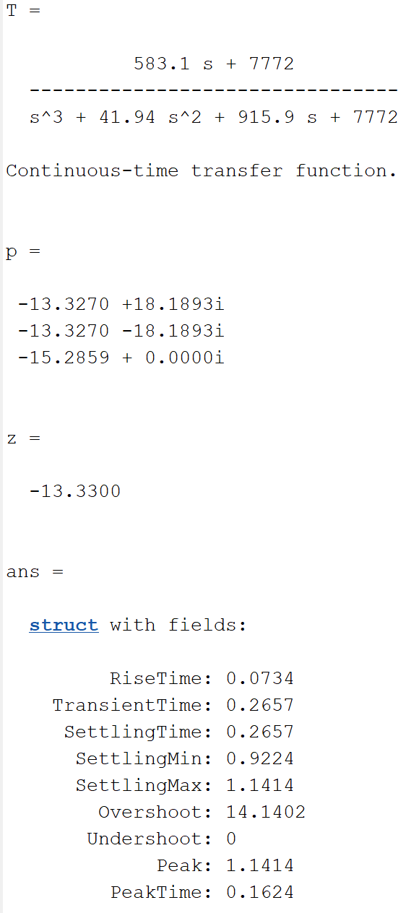

Step Response Plot:

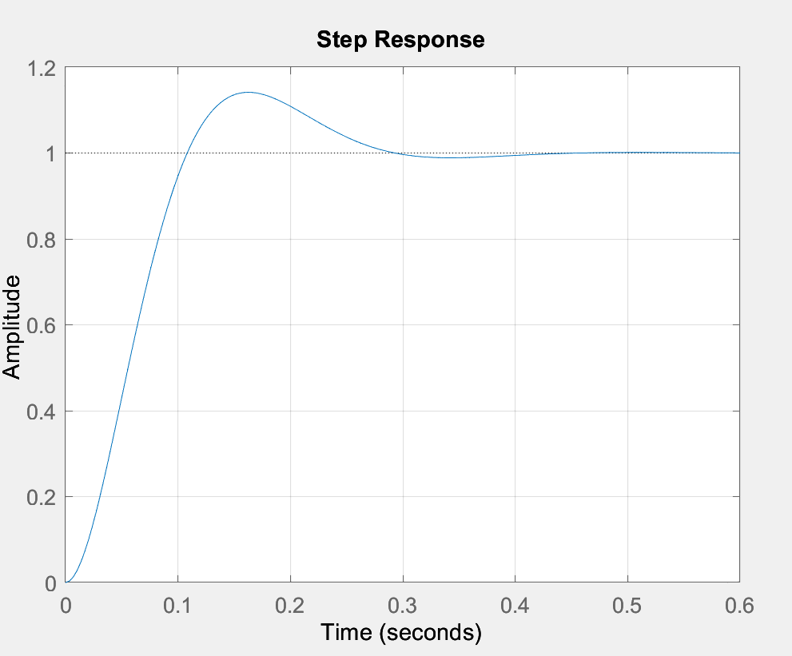

As seen from the above data and plot, there is an overshoot of approximately 14.14% and a settling time of around 0.27s. Thus, the Ts does meet the design requirement, but the P.O. is over the required P.O. of 10% . This discrepancy may be due to the fact that we our motor transfer function is of a second order, however the addition of the compensator introduces an extra pole and zero making the system a third order, thus the response does not perfectly match the ideal design specifications.

Experiment with Phase Lead Compensator

Step Response

Using the following Simulink model in MATLAB:
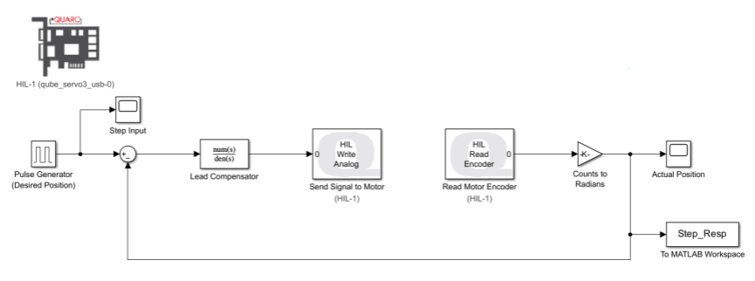
Results in the following experimental output:
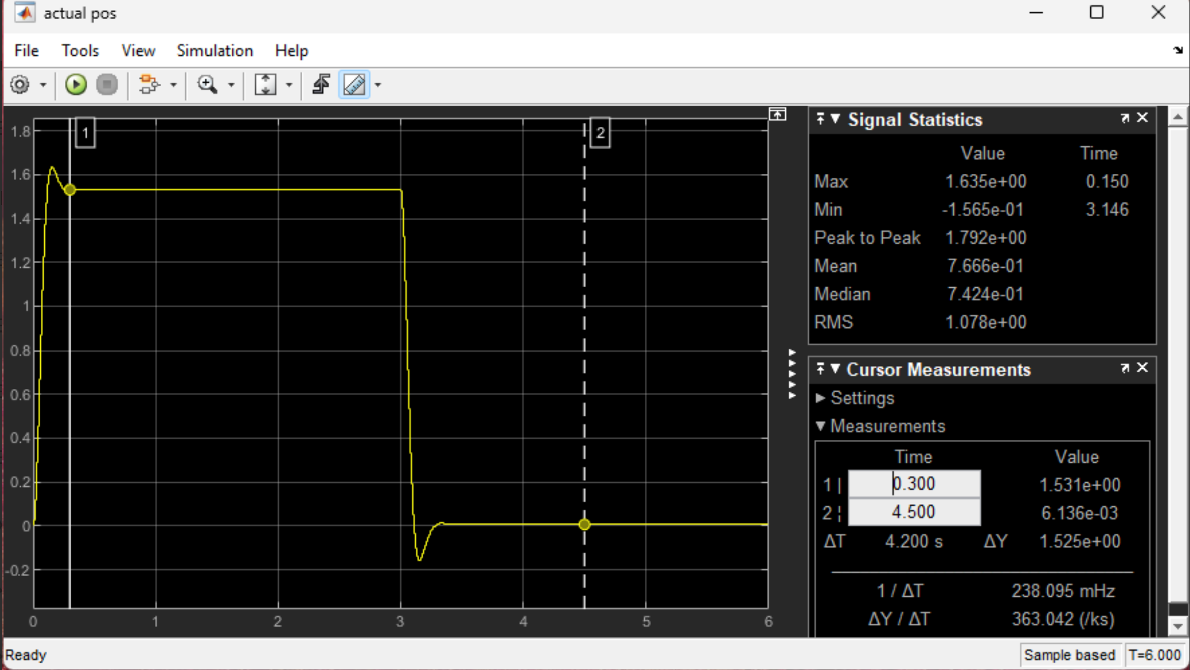

Verifying the control system design objectives are satisfied:
$$M_{p}=1.635 \\ f_{v}=1.531 \\ PO=\frac{M_{p}-f_{v}}{f_{v}}×100=\frac{1.635-1.531}{1.531}×100=6.8\% \\ T_{s}=0.3s$$
$$∴PO=6.8\% , T_{s}=0.3s$$

As seen from our P.O., it is under the requirements of the design i.e. P.O. of around 10%, however our Ts does meet the requirements. Our values and experiments were checked by the TA and our TA confirmed that the issue is with motor it self as it would have given inaccurate A and $τ_{m}$values from Lab 2, thus when trying to meet the design constraints of this experiment it was not possible. Although, it was expected that it would meet if it was not for our motor station.

Using the same following Simulink model in MATLAB, but with the transfer function block replaced with a gain block of $k_{c}=1.87$:

Results in the following experimental output:
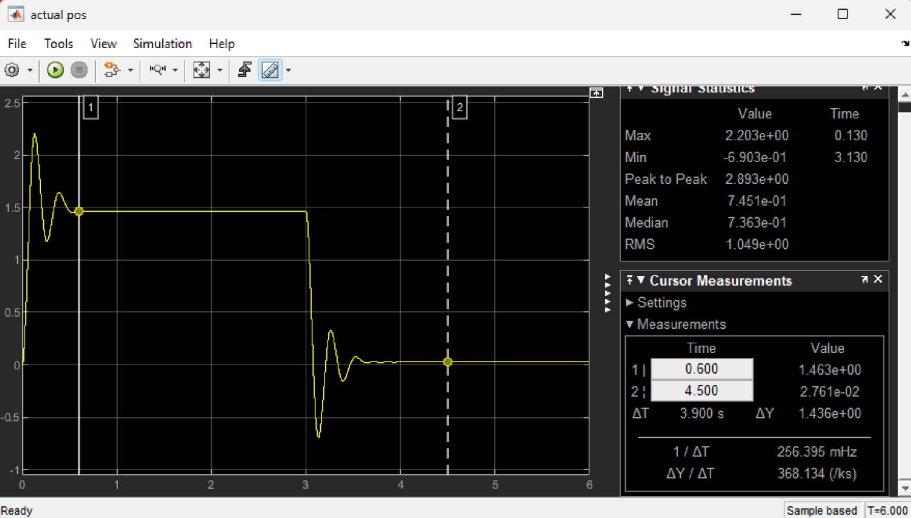
To verify the control system design objectives are satisfied:
$$M_{p}= 2.203 \\ f_{v}= 1.46 \\ PO=\frac{M_{p}-f_{v}}{f_{v}}×100=\frac{2.203-1.46}{1.46}×100=50.9\% \\ T_{s}=0.6s$$
$$∴PO=50.9\% , T_{s}=0.6s$$
As seen from the data above, when we redo the experiment without the lead compensator pole and zero, the design objectives are not met and are very far off compared to when we had the lead compensator. It is seen that the P.O. is almost 5 times the desired value and the Ts is twice the required settling time. In contrast, when we had the phase lead compensator, our settling time requirement was met where we had Ts = 0.3s, but the P.O. was under 10% where it was 6.8s but that’s due to our motor’s inaccuracy in addition it is way closer to meeting the design requirements than when using the gain block (without lead compensator). This all demonstrates that a proportional controller alone cannot meet both the design specifications of the percent overshoot and settling time simultaneously, whereas the phase lead compensator improves the transient response as seen by both plots by reducing overshoot and achieving the design requirements.

Ramp Response
Using the following Simulink model in MATLAB:
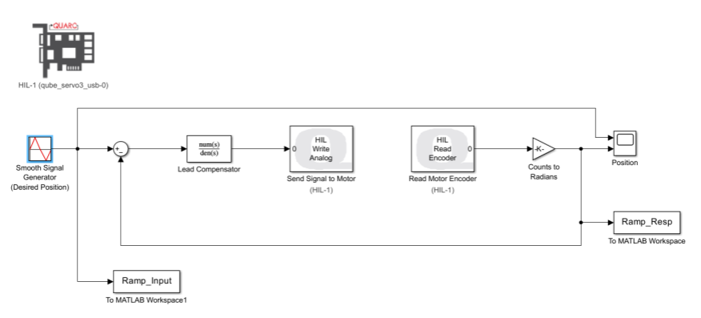
Results in the following experimental output:
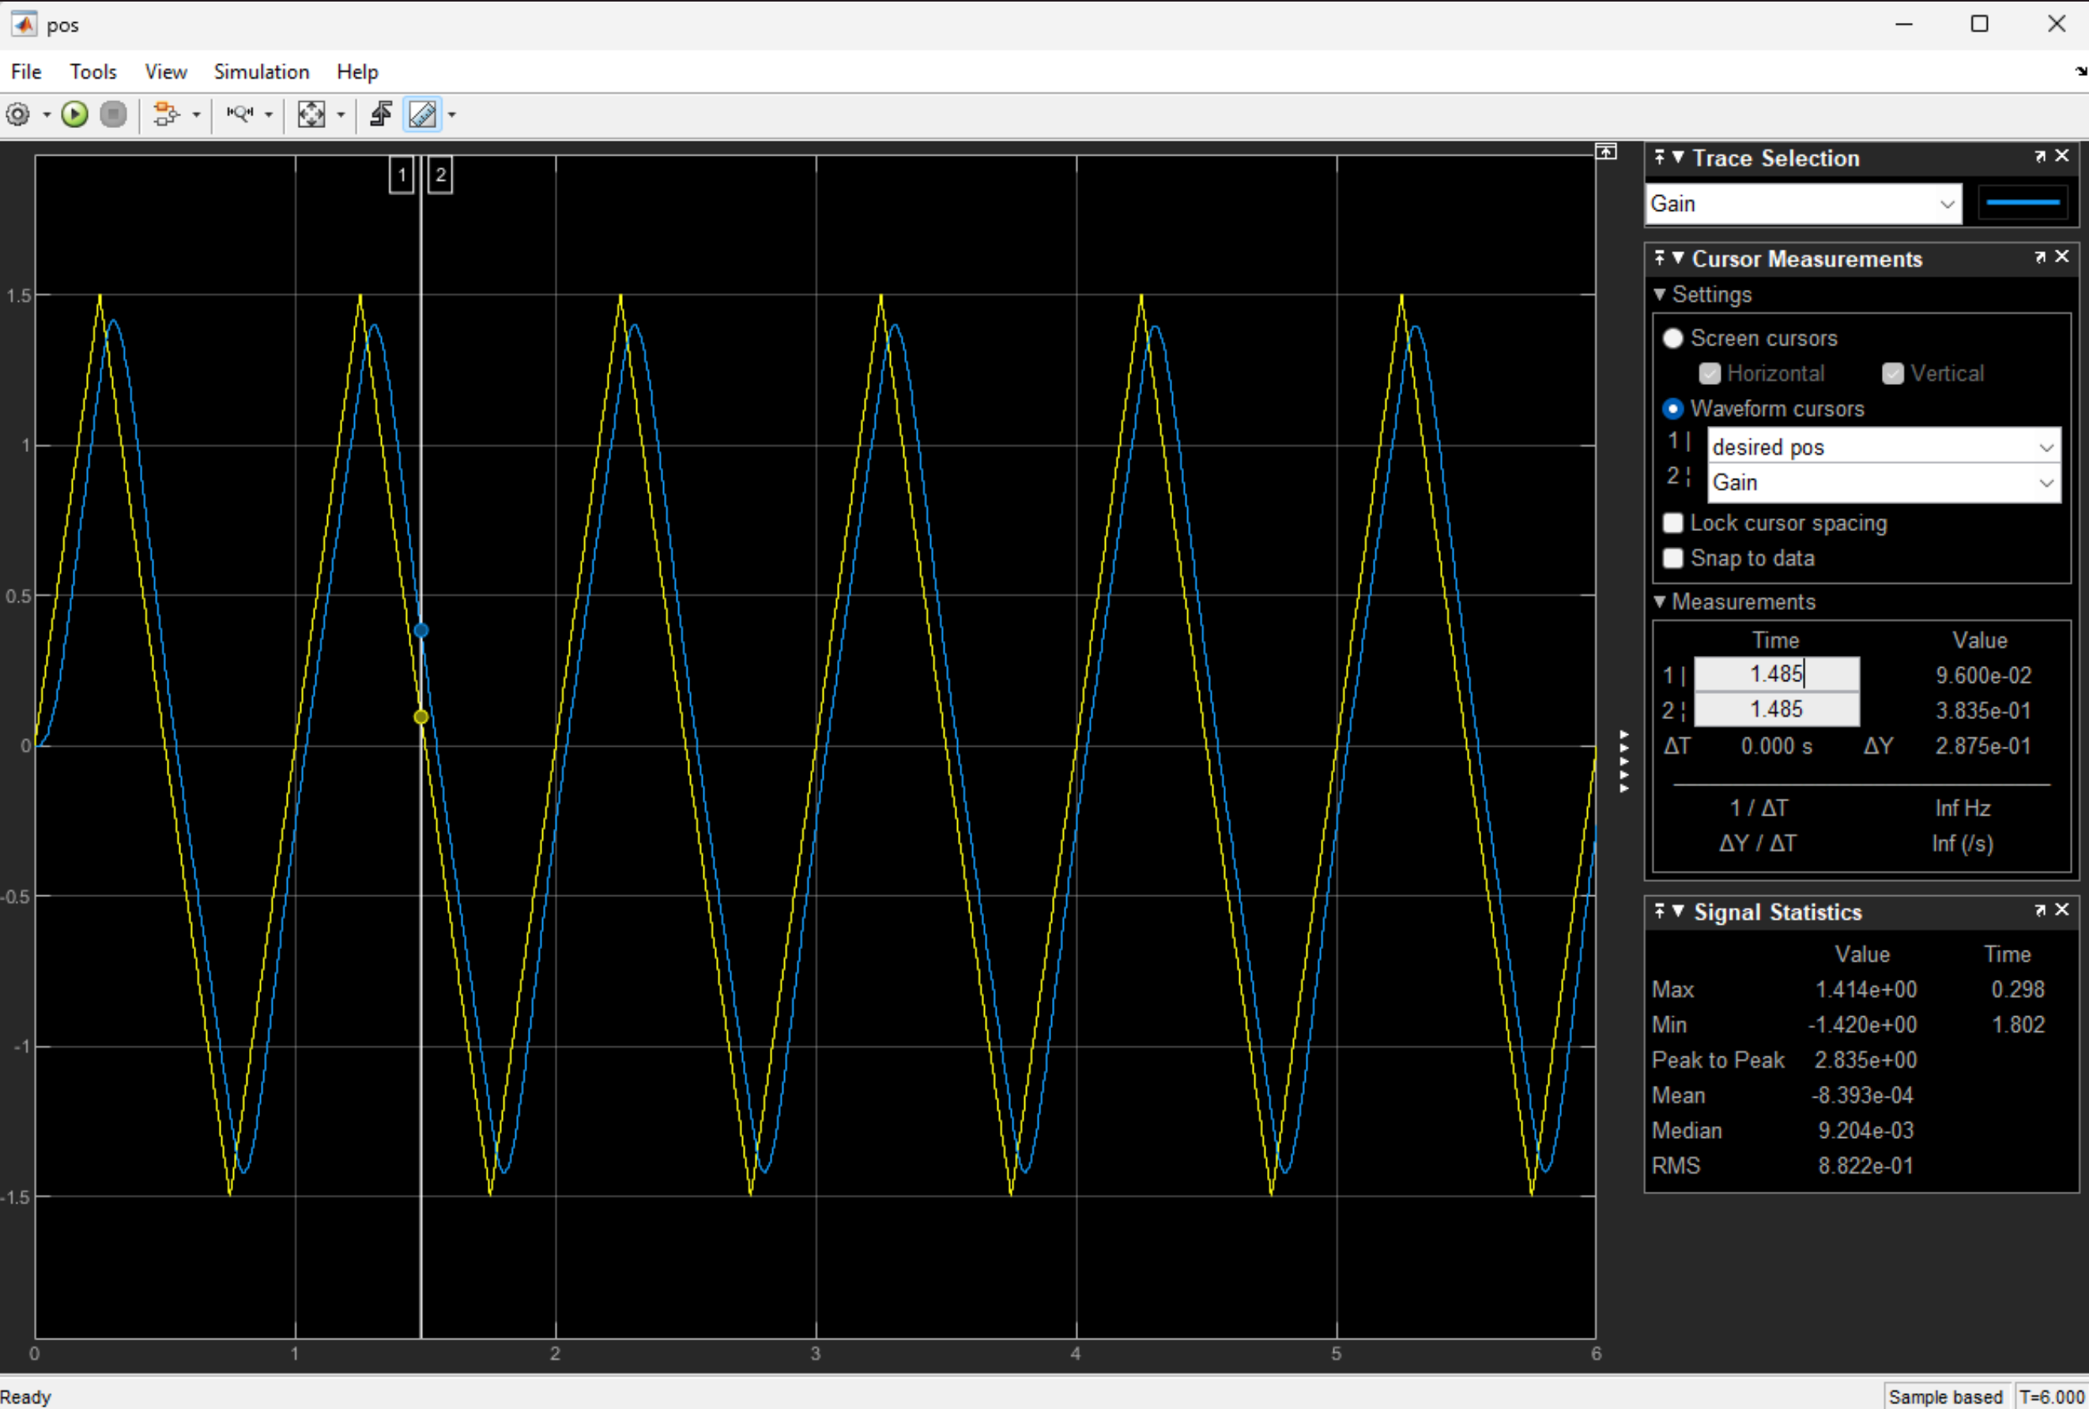
To calculate the experimental values of $k_{v} and e_{ss}$:
$$e_{ss}=y_{output}\left(t=1.485s\right)-y_{input}y_{output}\left(t=1.485s\right)=0.3835-0.0096=0.2875 \\ k_{v}=\frac{A_{input}}{e_{ss}}=\frac{Δy/Δx}{e_{ss}}=\frac{\frac{2.875}{0.484}}{0.2875}=\frac{5.938}{0.2875}=20.65$$
$$∴e_{ss}=0.2875 , k_{v}=20.65$$
This experiment was to see if we could meet the design requirements of the P.O. and Ts using a phase lead controller for a ramp response. As seen from the above data and plot, when finding the phase lead controller using a step input response of 6, we first found the steady state error which was 0.2875 by seeing both differences of the y values, then we did the step response input which was 6 divided this value of ess which was found to be 20.65. This value is very similar to our theoretical kv value that was based on our motor function and Ts = 0.3s and P.O. of 10% which was 23.35 and ess = 0.042 which shows that when introducing a phase lead controller, we can very closely meet our design specifications. The small differences between the measured and theoretical k and ess values may be from the motor inaccuracies such as those introduced in experiment 3.1 and verified by the TA.

